

Web course

2024



Q#1:

<!doctype html>

<html>

<head>

<title>

MY_PROFILE

</title>

</head>

<body>

<h1>

Name :<br> Abdullah<hr>

</h1>

<h2>

Roll number # : 21F_9248

</h2>

<p>

I am student of <b>BSCS</b> 6D section in fast national university.

</p>

</body>

</html>

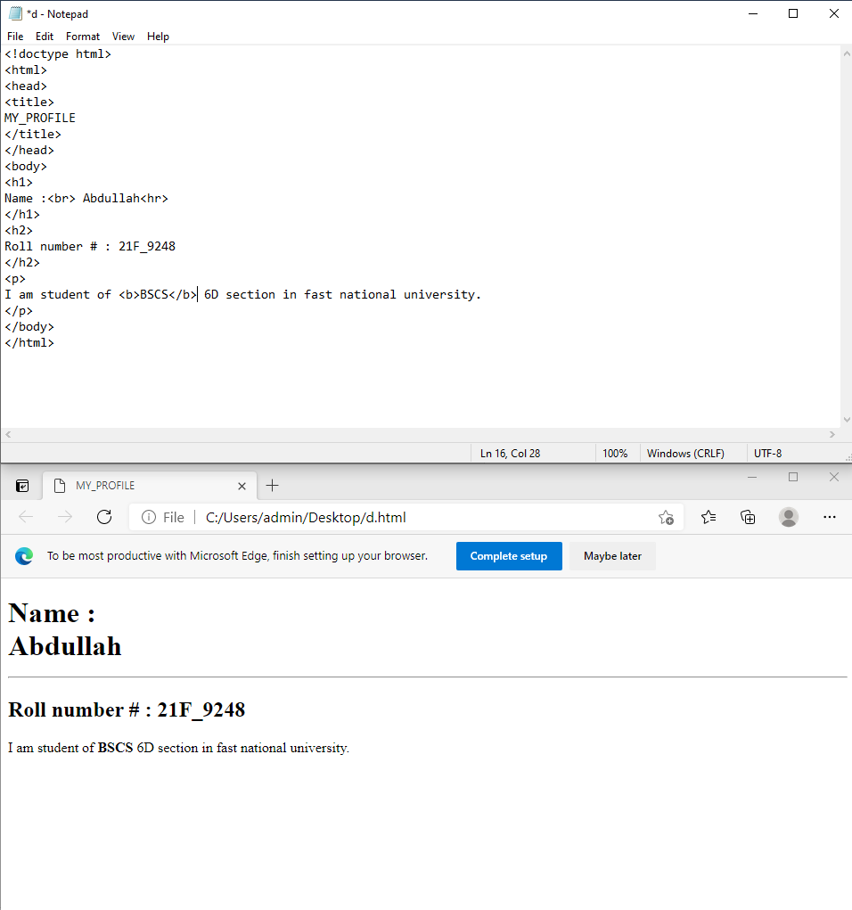

Q#2

<!doctype html>

<html>

<head>

<title>

MY_PROFILE

</title>

</head>

<body>

<h1>

This text is bold .<br> This text is strong.

</h1>

<p>

This is big. <br>This text is italic.<br> This text is emphasized.<br> This computer output.

</p>

</body>

</html>

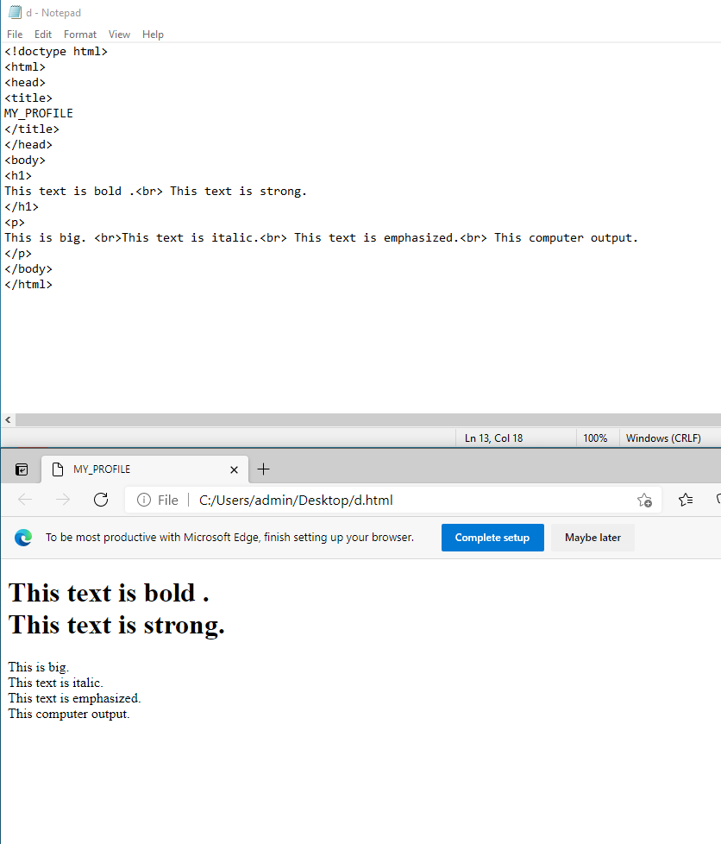

Q#3:

<!doctype html>

<html>

<head>

<title>

MY_PROFILE

</title>

</head>

<body>

<h1>

This text is Fast university logo .

</h1>

<p>

<img src="C:\Users\admin\Desktop\download.png"length="50"width="350">

</p>

</body>

</html>

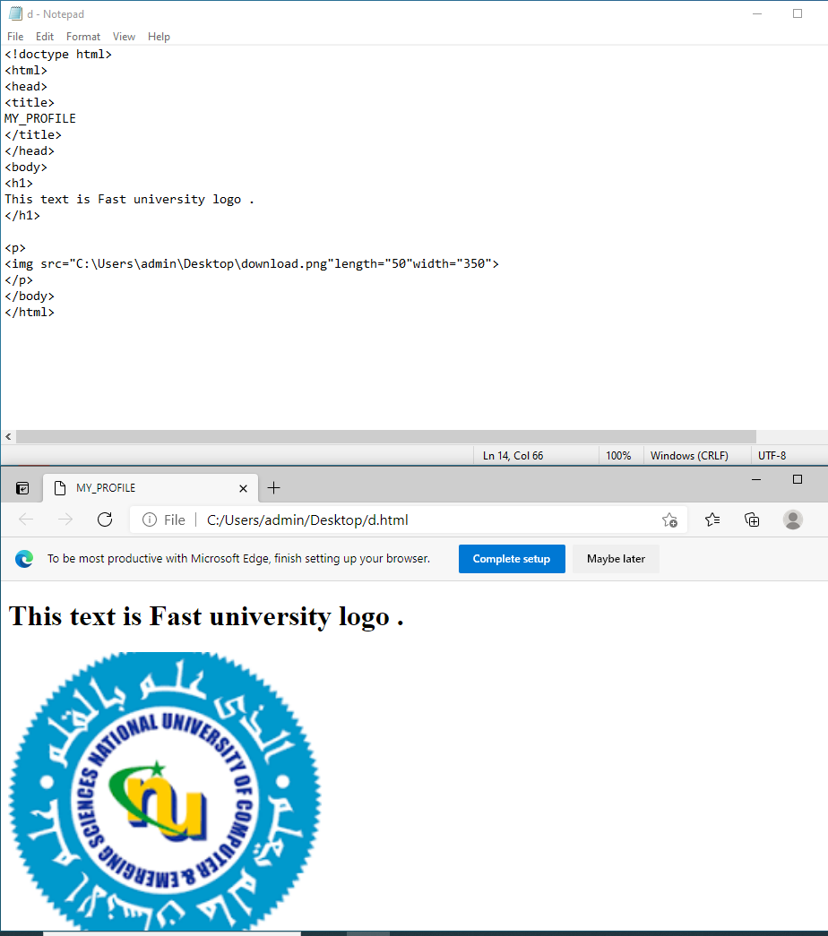

Q<!doctype html>

<html>

<head>

<title>

MY_PROFILE

</title>

</head>

<body>

<h1>

This text is Fast university lINK .

</h1>

<p>

<a href="https://www.nu.edu.pk/">GOTO TO FAST WEB PAGE BY CLICKING!</a>

</p>

</body>

</html> #4:

